4 LAB

1.

a) 3 phases. Initial phase – characterize fully the data needs of the prospective database users.

Second phase -- choosing a data model

• Applying the concepts of the chosen data model

• Translating these requirements into a conceptual schema of the database.

• A fully developed conceptual schema indicates the functional requirements of the enterprise.

▪ Describe the kinds of operations (or transactions) that will be performed on the data.

Final Phase -- Moving from an abstract data model to the implementation of the database

• Logical Design – Deciding on the database schema.

▪ Database design requires that we find a “good” collection of relation schemas.

▪ Business decision – What attributes should we record in the database?

▪ Computer Science decision – What relation schemas should we have and how should the attributes be distributed among the various relation schemas?

• Physical Design – Deciding on the physical layout of the database

b)

Entity Relationship Model (covered in this chapter)

• Models an enterprise as a collection of entities and relationships

▪ Entity: a “thing” or “object” in the enterprise that is distinguishable from other objects

• Described by a set of attributes

2.

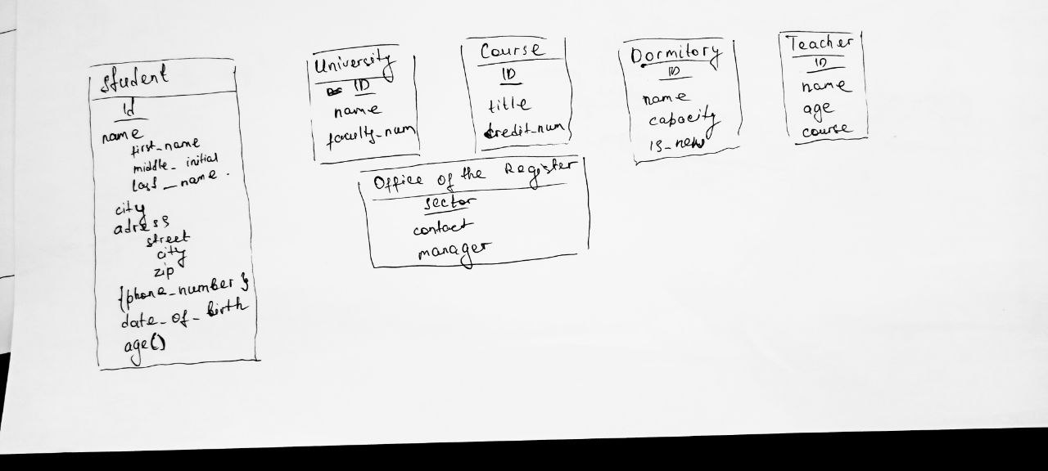

3.

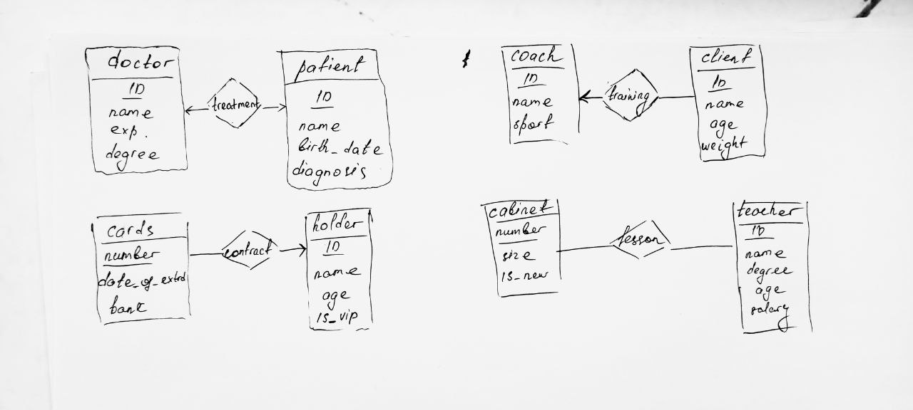

4.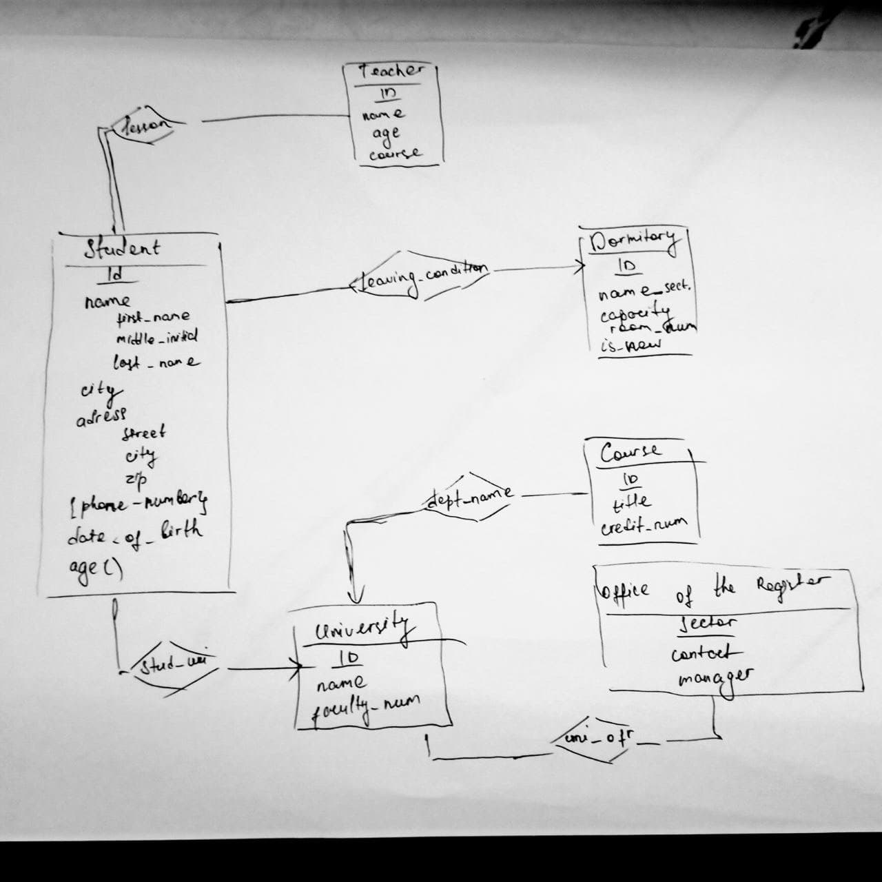

5.

